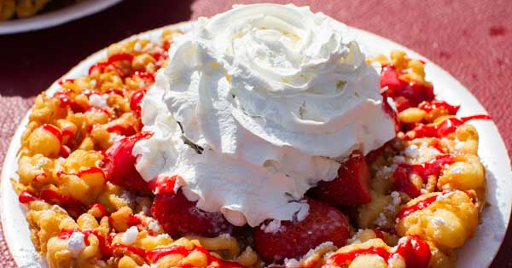
Fruit Topping Funnel Cake

Upgrade your funnel cakes with delicious toppings like strawberries and whipped cream! Fruit flavors are an ideal finishing touch. Also, try seasonal favorites such as apples in fall or cherries in winter.

Ingredients
- #5100 Pennsylvania Dutch Funnel Cake Mix
- Frying Oil
- 90 oz. Water
- #5140 World’s Greatest Toppings – Strawberry
- Powdered Sugar
- Strawberry Syrup
- Whipped Cream

Directions
- Preparing the Funnel Cake Batter
  - Place 90 oz. of water in a large container.
  - Using a blender on slow speed, or a whisk, slowly add the funnel cake mix.
  - Blend until the batter is smooth.
  - Pour the batter into a funnel pouring pitcher.
- Making the Funnel Cake
  - Fill your shallow fryer to the recommended level with vegetable oil and heat to 400 degrees F.
  - Place the funnel cake mold in the fryer.
  - Pour batter into the mold from a funnel cake pitcher, starting with a circle of batter near the outer edge of the mold, then making a zig-zag overlapping design touching the outer edge circle.
  - Do not overfill mold since the batter will expand as it cooks.
  - After approximately 30 seconds remove the mold and turn the funnel cake over with tongs to achieve a golden brown on both sides.
  - Remove the funnel cake and let it cool briefly.
  - Top with powdered sugar, ice cream, honey or any kind of your favorite toppings.
- Topping the Funnel Cake
  - Place a large scoop of strawberry topping on the top center of the funnel cake
  - Drizzle with strawberry syrup
  - Finish by topping with a generous dollop of whipped cream
  - Top with powdered sugar

