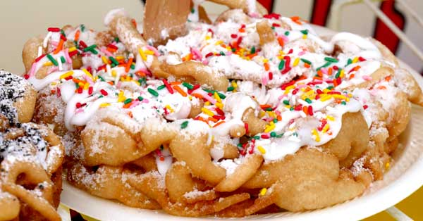
Birthday Cake Funnel Cake

The fun starts here with a delicious birthday cake funnel cake! Using the Signature Blends® Birthday Cake flavor, you’ll enjoy the taste of cake batter paired with mouthwatering toppings like icing and sprinkles.
Ingredients

- #5100 Pennsylvania Dutch Funnel Cake Mix
- Frying Oil
- 90 oz. Water
- 1/3 cup Birthday Cake Signature Blends #2439
- Icing
- Sprinkles
- Powdered Sugar

Directions
- Preparing the Funnel Cake Batter
  - Add Birthday Cake flavor to dry funnel cake mix and stir.
  - Place 90oz of water in large container.
  - Using a blender on slow speed, or a whisk, slowly add the funnel cake mix.
  - Blend until the batter is smooth.
  - Pour the batter into a funnel pouring pitcher.
- Making the Funnel Cake
  - Fill your shallow fryer to the recommended level with vegetable oil and heat to 400 degrees F.
  - Place the funnel cake mold in the fryer.
  - Pour batter into the mold from a funnel cake pitcher, starting with a circle of batter near the outer edge of the mold, then making a zig-zag overlapping design touching the outer edge circle.
  - For multiple colors in one cake, alternate pouring colors from separate pitchers.
  - Do not overfill mold since the batter will expand as it cooks.
  - After approximately 30 seconds remove the mold and turn the funnel cake over with tongs to achieve a golden brown on both sides.
  - Remove the funnel cake and let it cool briefly.
- Topping the Funnel Cake
  - Spread a layer of icing on the top of the funnel cake
  - Shake sprinkles generously on top
  - Finish by topping with powdered sugar
    - Other possible topping suggestions include whipped cream or ice cream

