Blueberry Popcorn – For a Mark 5 Gallon Corn Treat Cooker
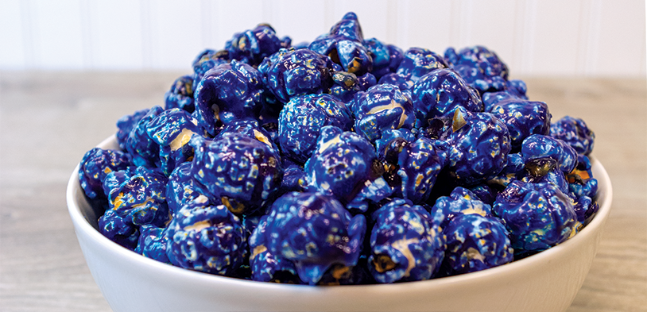
Pop up the color and flavor with Blueberry Candy Glaze. You can easily make delicious blueberry popcorn in a 5 gallon corn treat cooker. Recipe can be doubled for use in a 10 gallon corn treat cooker.

Ingredients
- 5 gallons of popcorn popped in white coconut oil
- 1 package of Basic Corn Treat Mix #2096
- 4oz. of white coconut oil #2654
- 4 cups of white sugar
- 12oz. of water
- 1 bottle of Free N Easy #2250QT
- 1/4 cup of Blueberry Signature Blends #2316

Directions
- Take lid off Mark 5 Cooker Mixer
- Turn on heat/motor switch on
- Add the following directly to the cooker mixer
  - 4oz. of white coconut oil #2654
  - 1 package of Basic Corn Treats Mix #2096
  - 4 cups of white sugar
  - 12oz. of water
- Place the lid back on the cooker mixer
- When buzzer sounds, turn heat/motor switch OFF
- Turn motor switch ON
- Take lid off the cooker mixer
- Add 1/4 cup of Blueberry Signature Blends #2316
- Add the 5 gallons of popped popcorn to the cooker mixer
- Tilt Cooker to 2nd position to let popcorn mix
- Spray 10 squirts of #2250Qt
- Let popcorn mix for 1 minute inside cooker mixer
- Dump popcorn into cooling tray
- Cool popcorn for 10 minutes by stirring popcorn constantly
- Bag or store popcorn

